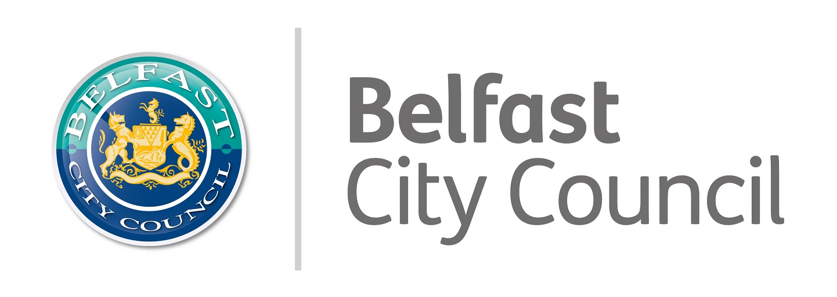

2 Royal Avenue – expression of interest form

A recent development in Council’s 2021 recovery programme for Belfast is taking on a meanwhile use space in the city centre as a new approach to experiential tourism and culture in the city. Opened in December 2021 this space delivers on many of the ambitions of the city’s cultural strategy and will be led by City Council Culture & Tourism teams, it will be housed in 2 Royal Avenue – the old Tesco supermarket. This pilot meanwhile cultural space will be a city collaboration to curate a series of experiences authentic to Belfast.

This project has been funded through Tourism NI’s Market Led Product Development Programme, working in partnership, to enhance the visitor experience within Belfast and Northern Ireland in support of the Northern Ireland Embrace a Giant Spirit campaign.

Council will work with city partners to curate a truly unique and creative programme of events for the space including music, food, visual art, performance and multi-disciplinary events, to look at new ways of telling stories, increasing ambition, taking creative risks, experimenting and co-creating with our visitors and citizens. This meanwhile use cultural venue pilot will run between December 2021 and March 2022:

- The space will operate 7 days a week with opening times and programming reflecting the gaps in the city’s current offer.
- There are 3 x dedicated pods for artists and creators to use for meetings, making work and running workshops (currently a drop-in system – booking may be required depending on demand)
- There is a large event space with a flexible layout for hosting a range of events (music/food/fashion/art/ markets/ talks/ theatre)
- 2 Royal Avenue will have a regular metamorphosis with creative partners coming on board to co-lead on creative content and programming with Council in this pilot phase.

Opening Hours:
Day of the week | Opening Hours - December 2021-March 2022
Monday to Tuesday | 10am - 6pm | Core hours
Wednesdays to Thursdays | 10am - 9pm | Core hours + specialist evening programming
Friday to Saturday | 10am - 7pm | Core hours + evening overlap
Sunday | 10am - 6pm | Core hours + specialist morning programming

** Completing this form does not guarantee a booking in the space. This form is used for us to assess demand and see if and how we can accommodate requests for bookings that complement and work alongside our proposed plans for 2 Royal Avenue**

We welcome proposals from organisations, groups and individuals

General principles for using 2 Royal Avenue space

Priority will be given to:
- Culture based events – music, food, fashion, visual art, science, environment, theatre, dance, literature, talks
- Free to access OR affordable ticketing (eg box office can be used to cover costs to run events)
- Opportunities to commission creators/ artists directly

Cost
- No hire fee
- Basic staffing coverage provided – Venue/Duty Manager, Event Sec door staff & security, general cleaning
- Standard audio/ visual equipment provided – stage/ lights/ PA & technician
- Booker responsible for hiring and operating additional equipment if required
- Booker responsible for covering extra event staffing costs if required
- Booker responsible for managing their own box office (tickets must be booked even with free access to manage numbers in the space)
2 Royal Avenue – Expression of Interest Form 2022
Contact name
Organisation (if applicable)
Address
Telephone |  |  | Mobile
Email
Website/ insta/ FB (if applicable)

Booking Query Details
Proposed Dates
Proposed Times
Space required | Front Section (Dome) | Back Section (Events Space) |  |  | Workshop Pods (3 available)
Event Name & Description
Proposed audience numbers
Proposed box office management
Technical requirements – A/V
Get in requirements
Catering requirements (we have an in-house café serving hot drinks and pastries, they can accommodate special requests)
Audience seating layout requirements
Public Liability Insurance – confirm cover and provider

Please return this form to culture@belfastcity.gov.uk

We have had a high demand to use the space so please bear with us and we will get back to you to discuss your proposal as soon as we can.

