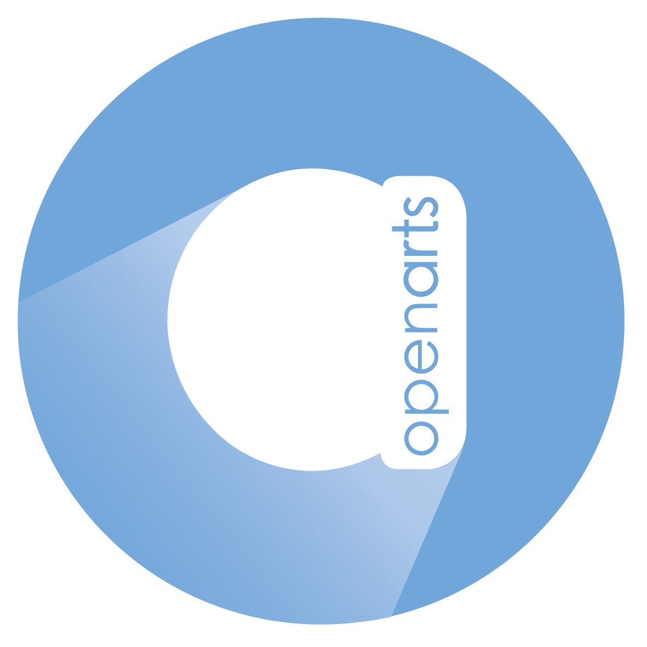
Inspiring and supporting the creativity and artistic development of disabled people

[image is of Open Arts logo, which is a blue circle with the letter a in the centre of it and the words open arts vertically along the stem of the letter a]

Open Arts

Communication & Development Assistant

Application Pack

April 2022
Closing Date and time for receipt of applications is
Friday 27th May 2022 by 12noon.

Completed applications will only be accepted by email to: eileen@openartsni.org

We will be in touch with every applicant on 2nd June to let you know if you have been selected for interview.
Interviews will happen on 9th and/or 10th June.

www.openartsni.org
Facebook.com/openartsbelfast
Twitter @openartsni

About Open Arts

Open Arts is an arts and disability organisation, which was founded in 1992. 50% of board members and two out of three current staff members have a disability.

For 30 years, Open Arts has been successfully running a core programme for disabled adults, which involves drama, dance, music, writing and visual arts. In addition, we produce multiple other stand-alone projects each year to engage more disabled people, including children & young people, in the arts.

There is no similar participatory work happening in Northern Ireland with the ambition and scope; multiple art forms with so many individuals with such varying disabilities and additional support needs: our activities engage people with physical disabilities, learning disabilities, sensory impairments and mental ill health.

We are a supportive, fun, inclusive organisation, which currently has 3 permanent members of staff and a wider, diverse team of freelance artists, volunteers and participants. We have an open-door policy in our office for our wider team (it has just resumed post covid!) so it is a vibrant, varied and social working environment. We keep a stock of custard cream biscuits, but we are always willing to expand our confectionery supplies.

Open Arts is an equal opportunity employer and welcomes applicants from all backgrounds. As a disability organisation, we would particularly welcome applications from disabled applicants.

Our Mission, Vision and Values

Our Mission – To inspire and support the creativity and artistic development of disabled people.
Our Vision – A society that actively values and promotes the creativity and artistic contribution of disabled people.
Our Values – Open Arts is committed to the following 5 values, which underpin every aspect of our work. Inclusion; Respect; Excellence; Integrity and Empowerment.

Job Description

Job Title: Communication and Development Assistant
Reports to: CEO
Overall Responsibility
Will take responsibility for our social media channels, web presence and digital archive and will assist the CEO with preparation of project/funding applications & reports while working with a range of organisations and people to deliver the aims of the organisation.

Specific Duties
Create accessible written, visual, video content for social media platforms, website content and to support PR activity.
Create and maintain an effective digital archive of the organisation’s work.
Assist the CEO in identifying and building relationships with prospective funders, supporters and project delivery partners from across various sectors (public, private and statutory).
Assist in the preparation of proposals and documentation in support of such projects.
Provide administrative support to the CEO as required.
Any other duties that may be reasonably required.

General Duties
To operate according to Open Arts mission and always demonstrate the values of Open Arts.
To work in accordance Open Art’s policies including, but not limited to, Safeguarding, Health and Safety, Equal Opportunities, Data Protection policies.
A commitment to equality and inclusion and to encouraging the involvement of all members of the community, particularly disabled people, in shaping Open Arts work.
To follow existing working practices, procedures and undertake relevant learning and development activities.
This role will include occasional evening and weekend work and a TOIL system is in place.

Job criteria

Experience
Experience of working in an administrative role (this can include volunteer work).

Knowledge
Working knowledge of Microsoft Office including MS Word and MS Excel.
Working knowledge of social media platforms including Twitter, Instagram, TikTok and Facebook (especially Facebook Business tools).
Working knowledge of developing engaging content for social media.

Skills
Strong communication and interpersonal skills.
Ability to present written information effectively for funding/project proposals & reports plus social media, website content and to support PR activity.
Self-motivated with ability to plan and prioritise including working to deadlines with good attention to detail.
Ability to work in a team and know when to seek help, support and advice.

Personal Qualities
Committed to equity and inclusion for disabled people.
Be flexible in support of the team, artists, volunteers and participants.
Be open and honest.
Be enthusiastic about arts and creativity

Other desirable criteria
Understanding of the funding landscape for the arts/charities
Working knowledge of video and audio programmes to edit and create social media/website content.
Understanding of Wordpress or similar web development/content management software.

Terms and Conditions

Salary: NJC Point 1, currently £18,333 gross per annum.
Hours of Work: This post is full time (35 hours per week) and based in Open Arts Office, Crescent Arts Centre, Belfast.
Pension: Open Arts provides employer pension contributions of 8%
Contract Length: This post is funded for a period of 3 years and any extension is subject to funding.
Annual Leave: 25 days plus 11 public holidays.
Learning and Development: This role will have the opportunity to work with a mentor and there is a dedicated skills development budget.

We are an inclusive organisation and therefore will consider a mix of office and home working.
Our office is based in the Crescent Arts Centre, which is physically accessible. We will work with the appointed person to assess any access requirements and make necessary adjustments and arrangements.

The Selection Process
You should apply using the format of the document below. We understand that some access technologies e.g. screen readers or speech to text do not do well with complicated forms so we have kept it very clear and straightforward. Similarly, we ask that you submit your application a Word Document i.e. not PDF as it will be inaccessible for some of our recruitment team.

If shortlisted for interview, we will discuss any access requirements with you and we also ask you to give us some details on the form below, this is not part of the selection criteria. We can also offer interview via zoom. We will give all interviewees details of what to expect. We anticipate that interviews will take place 9th and/or 10th June.

Once interviews have been completed, the successful person will be offered a conditional offer. This will be subject to satisfying any pre-employment conditions such as receipt of satisfactory references, proof of right to work, standard ACCESS NI check.
We will also ask for two referees when a conditional offer is made. Neither of these people should be related to you.

Closing Date and time for receipt of applications is:
Friday 27th May 2022 by 12 noon.

Completed applications will be accepted by email only to: eileen@openartsni.org
Application Form

Closing Date and time for receipt of applications is:
Friday 27th May 2022 by 12 noon. Completed applications will be only accepted by email as a Word Document attachment to eileen@openartsni.org

Please give the following details:

Full name:

Address:

Telephone number (preferably your mobile):

Email address:

Please give no more than 250 words in each of the 5 sections below:

Section 1: Let us know about any experience you have had in an administrative role including voluntary positions.

Section 2: Let us know about your working knowledge in relation to the criteria.

Section 3: Let is know about your skills in relation to the criteria.

Section 4: Let us know about your personal qualities in relation to the criteria.

Section 5: Please tell us anything else you would like us to know particularly in relation to the desirable criteria.

The following is not part of the selection criteria, it is so we can prepare for interviews. If selected for interview, please give brief details below of any access requirements you have.

