Dublin Theatre Festival Application Form
Name: | Email:
Phone: |  | Postcode:

Please give us a brief description of your work to date:

How will attending the Dublin Theatre Festival impact on your work? (300 words)

What are your future plans for your career in theatre and the performing arts and the work you’re currently making? (300 words)

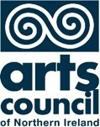The principal funder of Theatre and Dance NI is the Arts Council of Northern Ireland.

