Thank you for your interest in The Good Eggs: ENHANCE training programme. If you have any further questions about the programme or our work you can get in touch with our Community Engagement Officer, Aimee. You can contact Aimee at aimee@eastsidepartnership.com
Who is EastSide Arts?
As part of the EastSide Partnership, EastSide Arts is an arts regeneration charity that exists to create an east Belfast that is a thriving cultural hub; where the arts are valued, creativity is for everyone and people are connected with each other and the wider world.
Through our year-round creative engagement work, including the annual EastSide Arts Festival, we want to give anyone living, working or visiting Belfast the chance to be creative locally and on their own terms. Ultimately, we believe that creativity and equitable access to the arts is a fundamental right, and we design events, programmes and activities that help bring that belief to life.
At EastSide Arts we want to contribute to a more diverse and inclusive creative sector. We particularly encourage applications from artists who are disabled, immigrants, global majority and those from working class backgrounds. Based on our recent research into creative trends in the area, we are also interested in working with more male artists and with artists who specialise in textiles, dance/ movement or digital arts.
Process
ENHANCE is designed for professional artists who have paid experience of creative facilitation. We welcome facilitators with experience working anywhere in the world, in any setting, community based or commercial.
Please send your CV along with the completed application form below to aimee@eastsidepartnership.com by Midnight on Monday 1st April. Please ensure that your application form is no longer than two A4 pages. Alternatively, audio/video recording submissions are welcome, providing they do not exceed 4 minutes.
All applications will be acknowledged but late or postal applications will not be accepted. Confirmation for successful applicants will be sent out on Thursday 4th April.
The facilitation training day will take place on Friday 19th April 2024, 10am – 4pm at Walkway Community Centre 1-9 Finvoy Street, Belfast BT5 5DH.
All attendees will be paid a £50 fee via invoice / BACS payment for general expenses incurred.
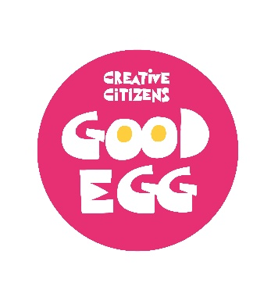
Please check the box to confirm that you are available to attend the training day from 10am – 4pm on Friday 19th April 2024 ☐
Tell us a bit about your experience as a creative facilitator and the settings you have worked in.
Click or tap here to enter text.

What is a challenge you have faced in your facilitation that you think you may be able to overcome with more support and training?
Click or tap here to enter text.

What interests you about working as a creative facilitator in east Belfast?
Click or tap here to enter text.

