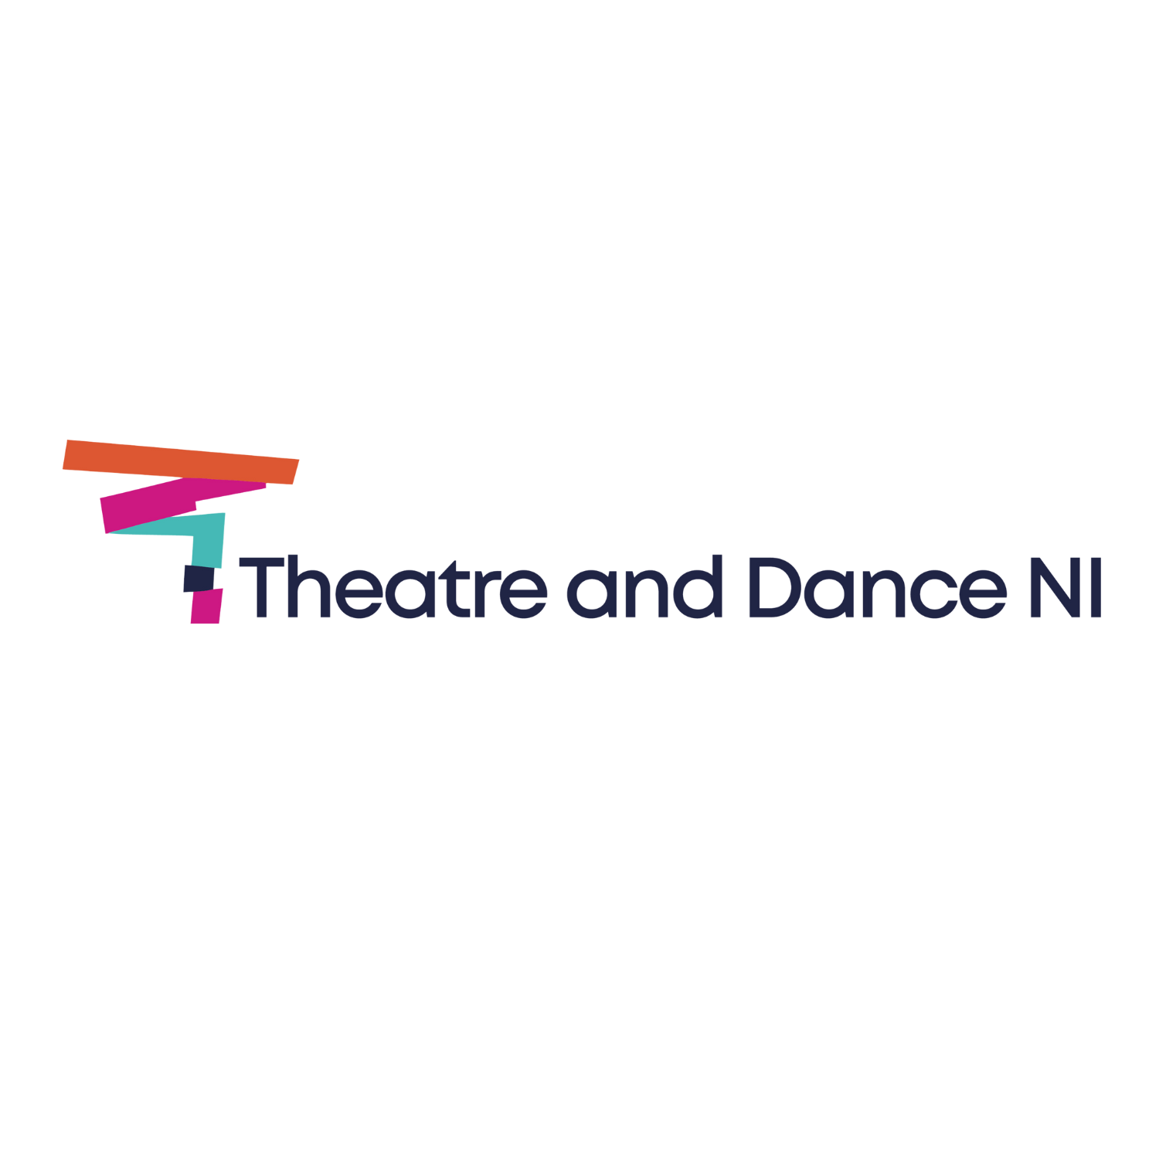

Dublin Dance Festival Bursaries 2025

Name of applicant *
Email *
Job Title *
Address of Applicant *
Postcode
Tel *
Mobile *
Website
Facebook
Twitter
Instagram

Please indicate here if you are a member of Theatre and Dance NI? YES/NO

Please indicate here if you are free from 21st – 23rd May 2025? YES/NO

Please set out why your participation at Dublin Dance Festival is important at this point to you or your company's professional development [maximum 300 words] *

